TEMPLATE
Extended Abstracts (Pecha Kucha) – Maximum 500 words

This document provides a template for an Extended Abstract (Pecha Kucha) submission for the ASCILITE 2019 conference. All submissions must use the correct formatting. Word Styles (on the home panel) are shown in block quotes with examples below.

Extended Abstracts are an opportunity to share and showcase innovative Technology Enhanced Learning (TEL) practice through a Pecha Kucha presentation. Extended Abstracts may feature practice-based examples such as Scholarly Practice, learning innovations, professional development innovations, outcomes of communities of practice, etc. Extended Abstract submissions are a maximum of 500 words, not including references.

The authors must have the copyright to all the material used in the submission or received written permission to use the protected material.

Before you submit the final version of your paper, please ensure you adhere to the following criteria:
- the submission file is in one of the following: Microsoft Word, PDF, or OpenOffice document file format
- the entire document is formatted based on this template
- all URL addresses included must be activated
- all authors’ names must be removed from the submission, with author and year used in the bibliography and footnotes instead of the authors’ names
- all Microsoft Office documents (including Supplementary Files) have been saved by going to File and selecting Save As; clicking Tools (or Options in a Mac); clicking Security; selecting "Remove personal information from file properties on save"; clicking Save
- submission size is limited to 20MB, please ensure you are using images in a compressed format to keep file size low.

For any questions regarding submission or this template, please contact our ASCILITE 2019 Event Organisers at ascilite2019@suss.edu.sg.

Insert your title here [Paper title style]

Place your abstract here ... no more than 200 words …[Abstract and keywords style]

Keywords: One line of key or focus terms by which your paper can be indexed. [Abstract and keywords style]

First level heading [First level heading style]

Body of your paper … use Times New Roman 10 point, left aligned, single spaced. Blank lines before and after headings and paragraphs are to be sized the same as text lines, i.e., 10 point (Times NR).

For paragraphing, use a single blank line between each paragraph, and no indents. Do not use Spacing Before or Spacing After your paragraphs. [Paper body style]

Second level heading [Second level heading style]

Put a blank line before and after the second level heading. [Paper body style]

Third level heading [Third level heading style]
Do not include a blank line after a third level heading. Use bulleted or numbered lists in preference to third level headings where possible. [Paper body style]

[This is a quotation] Use Times New Roman 10 point, left aligned, single spaced, indented 1.0 cm left and right, not italicised, without quote marks, one blank line before and after. Indents may be varied slightly from 1.0 cm to improve the fit. Referencing for the quotation may be given in the running text immediately before the quotation, or may be appended to the end of the quotation. In general, very short quotations using only a few words should be given with quote marks in your running text, whilst only longer quotations using a line or more should be formatted as quotations. (reference) [Quotation style]

This is a bulleted list:

• Times New Roman 10 point
• left aligned, single spaced
• no indents except a hanging indent 0.5 cm.[Bulleted List style]

This is an ordered list:

- Times New Roman 10 point
- left aligned, single spaced
- no indents except a hanging indent 0.5 cm. Indentation may be varied slightly to improve the fit.
- select only from these kinds of ordering: 1., 2., …; i., ii., …; a., b., … Do not use any other kind. [Ordered list style

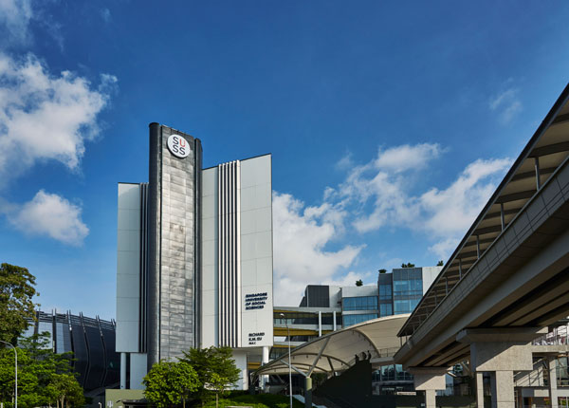

Figure 1: Sample of a figure (legend is below figure) [Figure style]

Figures must be placed in their correct location in your running text. All figures should be included in your Word file, and not in separate graphic or drawing package format. Labeling should be consistent with the fonts used in the text of your paper, i.e., Times New Roman. Number sequentially, Figure 1, Figure 2, etc. Do not use variations such as Figure 1a, 1b.

Table 1: A sample table (title is above table, centred, bold) [Table title style]

Location [Paper Body style] | Tables must be placed in their correct, appropriate locations in your running text [Paper Body style]
General | In general use Times New Roman 10 point and other body text specifications for all text within a table and its title, though 9 point may be used as required for narrow columns. Tables should have a title with consecutive numbering (e.g.: Table 1: Title of the table), bolded, using sentence case, centred, and located at the top of the table. For headings within tables use sentence case, with bold and centering optional.
Format | Centre each table and select appropriate widths for the table and for each column, using percentages. Use of borders for all cells ('All', with style '1/4 point') is recommended, mainly because borders seem to be helpful for on screen reading. In columns of numbers, use centre or decimal point alignment.
Explanatory text | If your table requires explanatory text that is inappropriate for placing in your running text, place it at the bottom of the table, formatted to the same width as the table.
Other features | Cell background colouring or shading may be used, but check that grey scale printing (600 dpi) is not impaired, and note that when a web version file is created, the Proceedings editors may use a standard background colour for the first row or other elements of a table.

References [First level heading style]

Use APA 6th edition style for references. This style prescribes alphabetical order by first author. Use Times New Roman 10 point, left aligned, hanging indent 0.5 cm, with no blank lines. Wherever possible, insert URLs for references. However, do not insert URLs for publications that only offer pay per view, institutional subscriber, or on campus only access to full text. The date of viewing may be omitted for journal and proceedings URLs considered to be of high reliability. The following list provides examples of referencing for the main kinds of publications:

Ally, M. (Ed.) (2009). Mobile learning: Transforming the delivery of education and training. Athabasca University Press (e-book). http://www.aupress.ca/index.php/books/120155
Gerbic, P. & Maher, M. (2008). Collaborative self-study supporting new technology: The Mahara e-portfolio project. In Hello! Where are you in the landscape of educational technology? Proceedings ascilite Melbourne 2008. http://www.ascilite.org.au/conferences/melbourne08/procs/gerbic.pdf
Gunn, C. & Peddie, R. (2008). A design-based research approach for eportfolio initiatives. In Hello! Where are you in the landscape of educational technology? Proceedings ascilite Melbourne 2008. http://www.ascilite.org.au/conferences/melbourne08/procs/gunn.pdf
Herrington, A. (2008). Adult educators’ authentic use of smartphones to create digital teaching resources. In Hello! Where are you in the landscape of educational technology? Proceedings ascilite Melbourne 2008. http://www.ascilite.org.au/conferences/melbourne08/procs/herrington-a.pdf
Kearsley, G. (2004). Explorations in learning & instruction: The theory into practice database. http://tip.psychology.org/ [viewed 13 Mar 2009].
Lefoe, G., Philip, R., O'Reilly, M. & Parrish, D. (2009). Sharing quality resources for teaching and learning: A peer review model for the ALTC Exchange in Australia. Australasian Journal of Educational Technology, 25(1), 45-59. http://www.ascilite.org.au/ajet/ajet25/lefoe.html
Levy, P. (2006). 'Living' theory: A pedagogical framework for process support in networked learning. ALT-J: Research in Learning Technology, 14(3), 225-240. [verified 20 May 2009] http://repository.alt.ac.uk/138/
Salmon, G. (2000). E-moderating: The key to teaching and learning online. London: Kogan Page. [References style is used for all the above references]

